“But if any of you lacks wisdom, let him ask of God, who gives to all generously and without reproach, and it will be given to him.”
-- James 1:5
- Please show all your work! No partial credit will be given for incorrect answers with no work shown. Please draw a box around your final answer.
- Give exact answers to all questions unless otherwise noted.
- Calculators are permitted, but no notes, text, laptops, PDAs, or electronic dictionaries.
- No sharing of calculators, and no communication with anyone other than the instructor.
- Cell phones should be muted and left in your pocket or bag.
Total marks: 70

- Let y = 10^{x}. Simplify in terms of x: log(0.001 y²). [3]
2x - 3
- $5000 is deposited in an account earning 6.25%.
  - With semi-annual (twice a year) compounding, what is the effective annual rate? [2]
≈6.3477%
  - What is the future value after ten years? [2]
$9252.29
  - With monthly compounding, what is the effective annual rate? [2]
≈6.4322%
  - With continuous compounding, [2]
what is the effective annual rate?
≈6.4494%
  - With continuous compounding, what is the doubling time of the investment? [3]
11.09 years
- Solve for x: 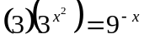 [4]
-1
- Simplify and compute approximate answer using calculator: 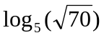 [3]
(1/2) ln(70)/ln(5) ≈ 1.3199

- Consider the series:
2, 2.02, 2(1.01)², 2(1.01)³, …, 2(1.01)³⁵.
  - Express the series in summation form (i.e., using ∑). [2]
∑2(1.01)^{k}, from k=0 to k=35
  - Compute the sum. [3]
≈86.154
- The half-life of carbon 14 (C-14) is estimated to be 5730 years. The C-14 level (actually, the ratio of C-14 to C-12) in a papyrus scroll is measured to be 72% of the level it is assumed it had when new. Estimate the age of the papyrus. [5]
2715 years old
- A client has a $600 debt that is 12 months past due, a $700 debt that is coming due in 2 months, and a $400 debt that is due in 8 months. Assume interest is 12% compounded monthly.
  - How much would the client need to pay off all three debts now at once? [4]
$1731.70
  - The client can’t afford to pay the lump sum now, so you setup a payment plan where the client makes payments at the end of each month for the next five months, plus one payment today. If the payments are all to be equal amounts, how much should each payment be? [4]
$295.84
- How much principal do you need to fund a perpetuity that pays $15,000 every year? Assume interest at 8% compounded continuously. [4]
$180,099.99
- You are thinking of buying a house, so you need to estimate how big of a loan you can afford. Assume your take-home pay is $4000 per month, and you can spend 30% of that on the mortgage. The current mortgage interest rate is 5% compounded monthly, and payments are made at the end of each month.
  - How big of a mortgage can you afford if the amortization length is 20 years? [6]
$181,830.38
  - What is the total interest paid (i.e., finance charge) over the lifetime of the loan? [3]
$106,169.62
  - This mortgage is not enough to buy a new 2-bedroom townhome in Langley, so you consider extending the amortization length to 30 years. Now how big of a mortgage can you afford? [4]
$223,537.94
  - But there is a price to be paid! Calculate the total interest on the 30-year loan. Which loan would you go for? [2]
$208,462.06, nearly twice that of the 20-year loan!
- Your web project requires both Development and Graphic Design work. There are two teams that you can hire to do the work: one in Vancouver and one in Calgary.

The Vancouver team can do 60 worker-hours of development and 100 worker-hours of graphic design for every week you hire them, and each week of work costs $7000.

The Calgary team can do 120 worker-hours of development and 40 worker-hours of graphic design for every week you hire them, and each week of work costs $2700.

The project needs 2400 worker-hours of development and 1200 worker-hours of graphic design, and it needs to be completed within 30 weeks (both teams can work in parallel).

Graph and shade in the feasible region for this problem. How many weeks of work should you hire from each team, in order to minimize cost? [12]

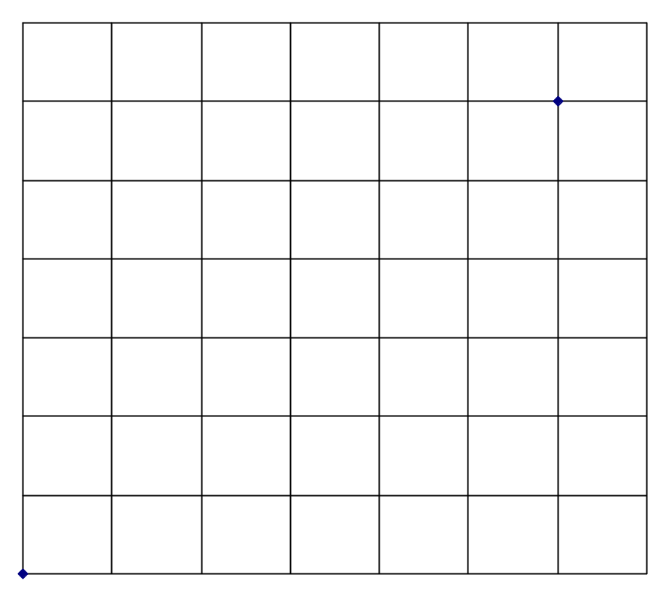
Dev: 60V + 120C ≥ 2400. Intercepts: (V=0, C=20), (V=40, C=0)
Graphics: 100V + 40C ≥ 1200. Intercepts: (V=0, C=30), (V=12, C=0)
Also, 0 ≤ V ≤ 30 and 0 ≤ C ≤ 30.
Corners and cost:
@(V=5, C=17.5): Cost = $82,250
@(V=30, C=5): Cost = $223,500
@(V=0, C=30): Cost = $81,000
@(V=30, C=30): Cost = $291,000

